**SPRINT – 1**

|  |  |
| --- | --- |
| **Date** | 30 October 2022 |
| **Team ID** | PNT2022TMID02664 |
| **Project Name** | Smart Waste Management System for Metropolitan Cities |
| **Story points** | 20 |

Step-1: Login to the IBM Cloud Account

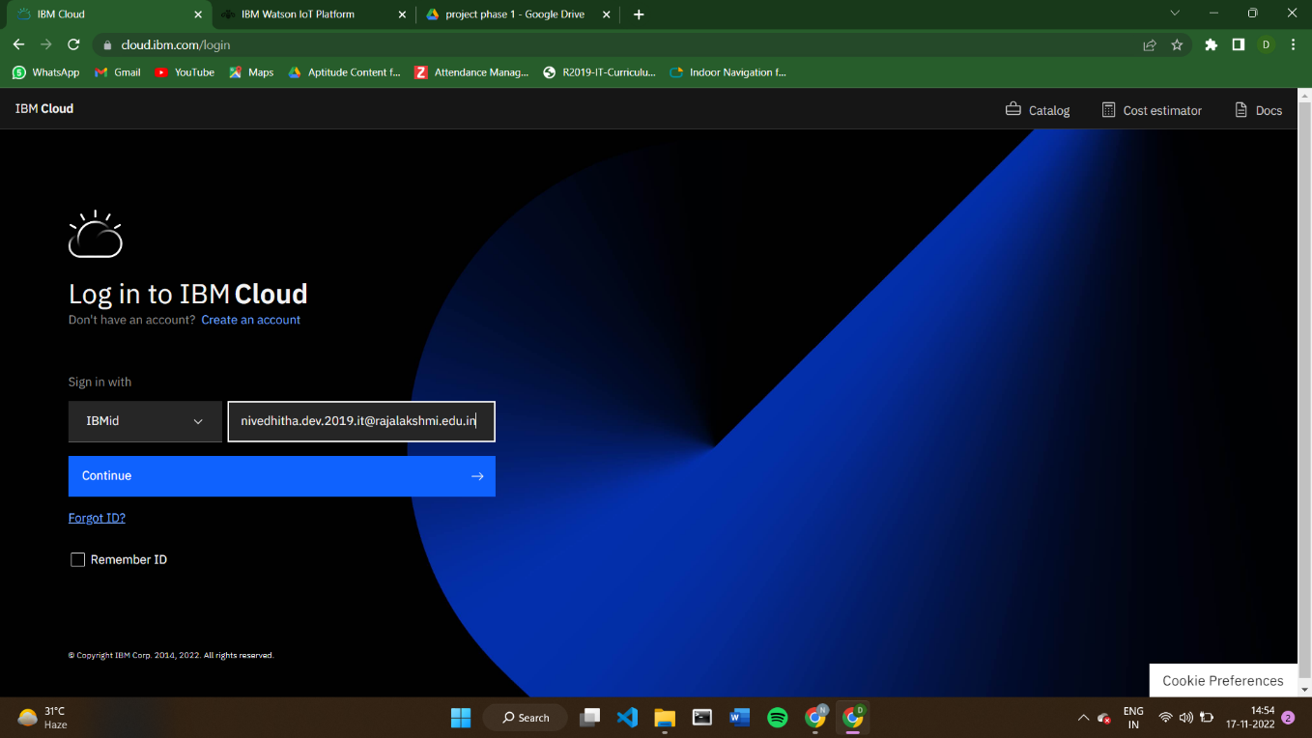

Step 2: Using IBM CLOUD services for the Project

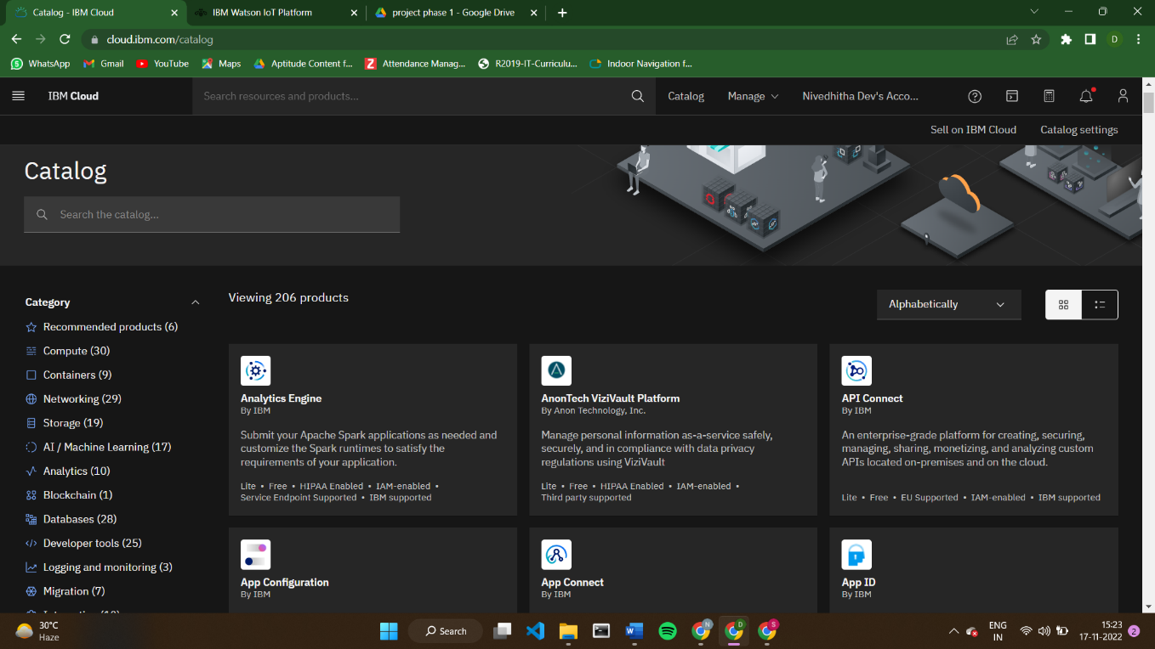

Step – 3: configure and launch the IBM Watson IOT platform

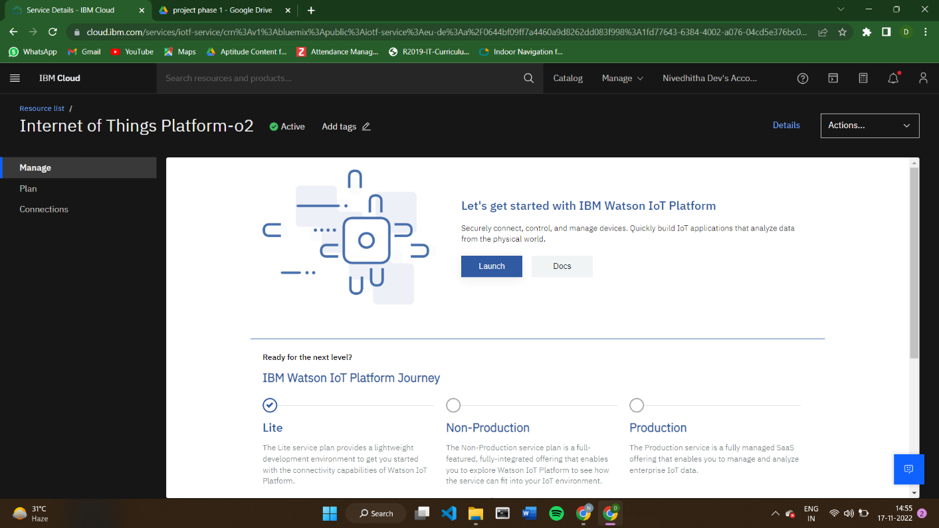

Step – 4: Sign in to the IBM Watson IOT platform

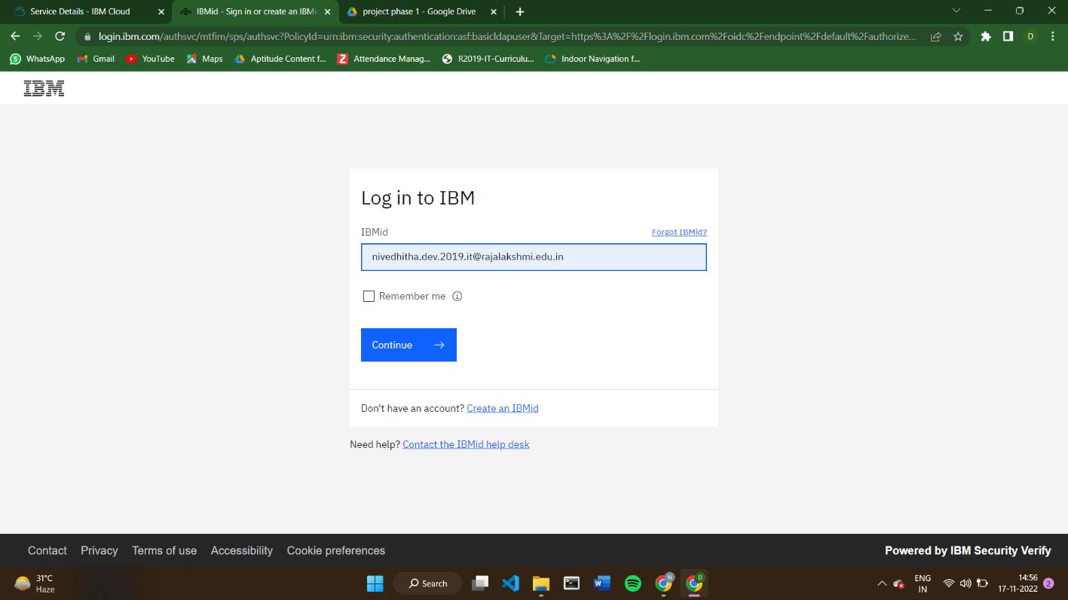

Step – 5: IBM Watson IOT platform is created

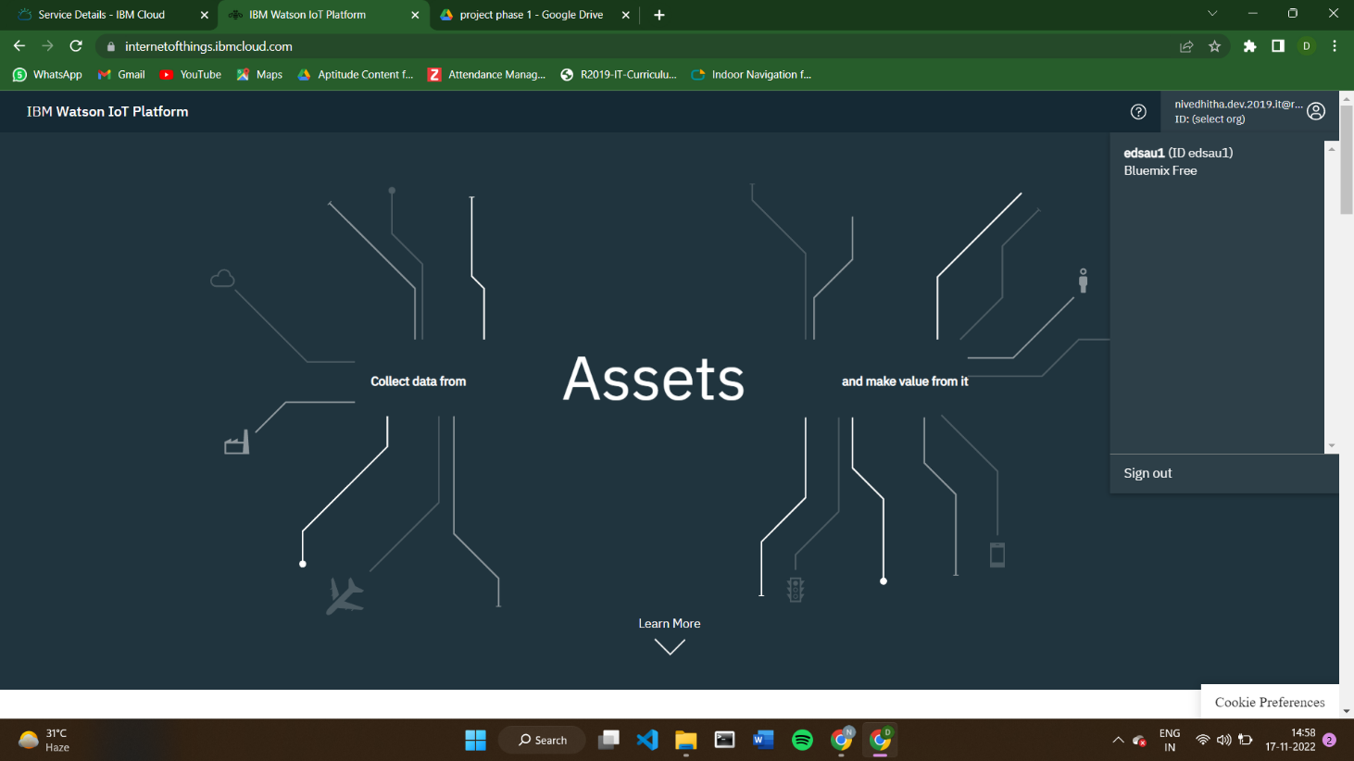

Step – 6: Open the IBM Watson IoT platform

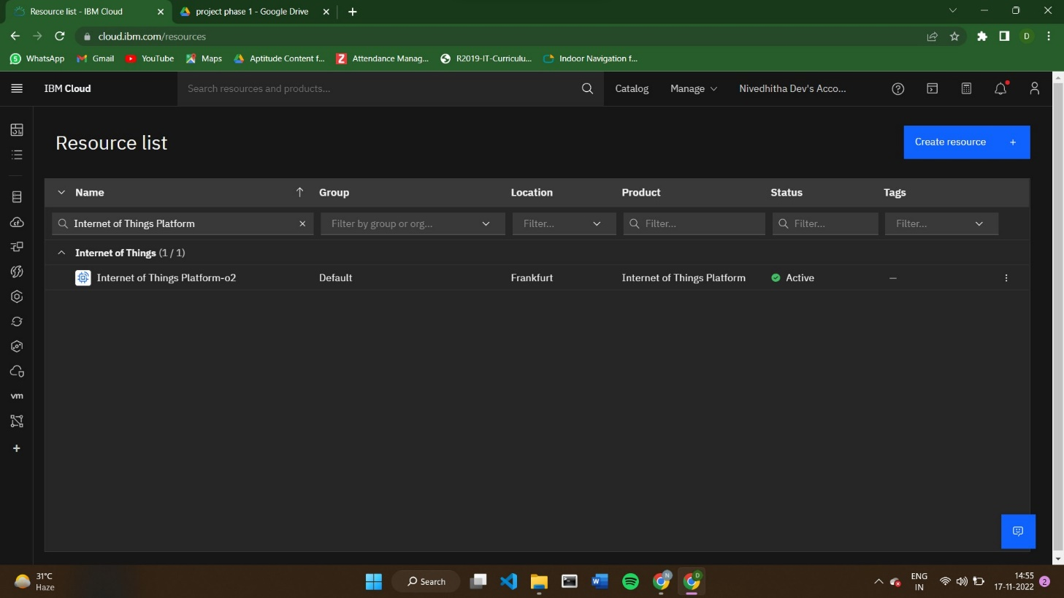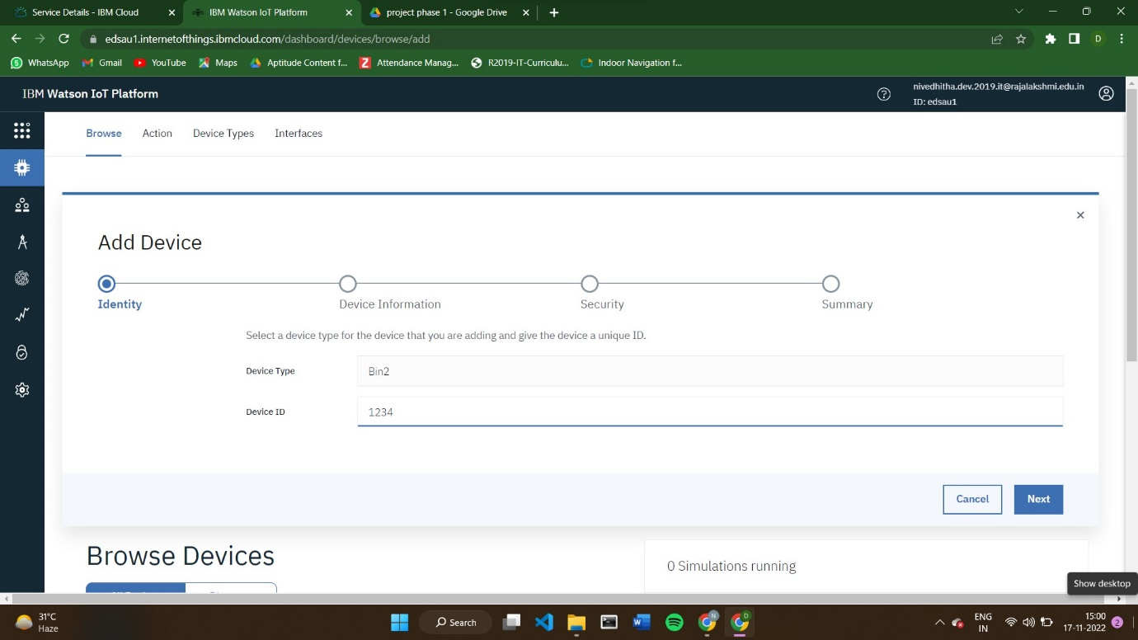

Step – 7: Add devices to the IBM IoT Platform.

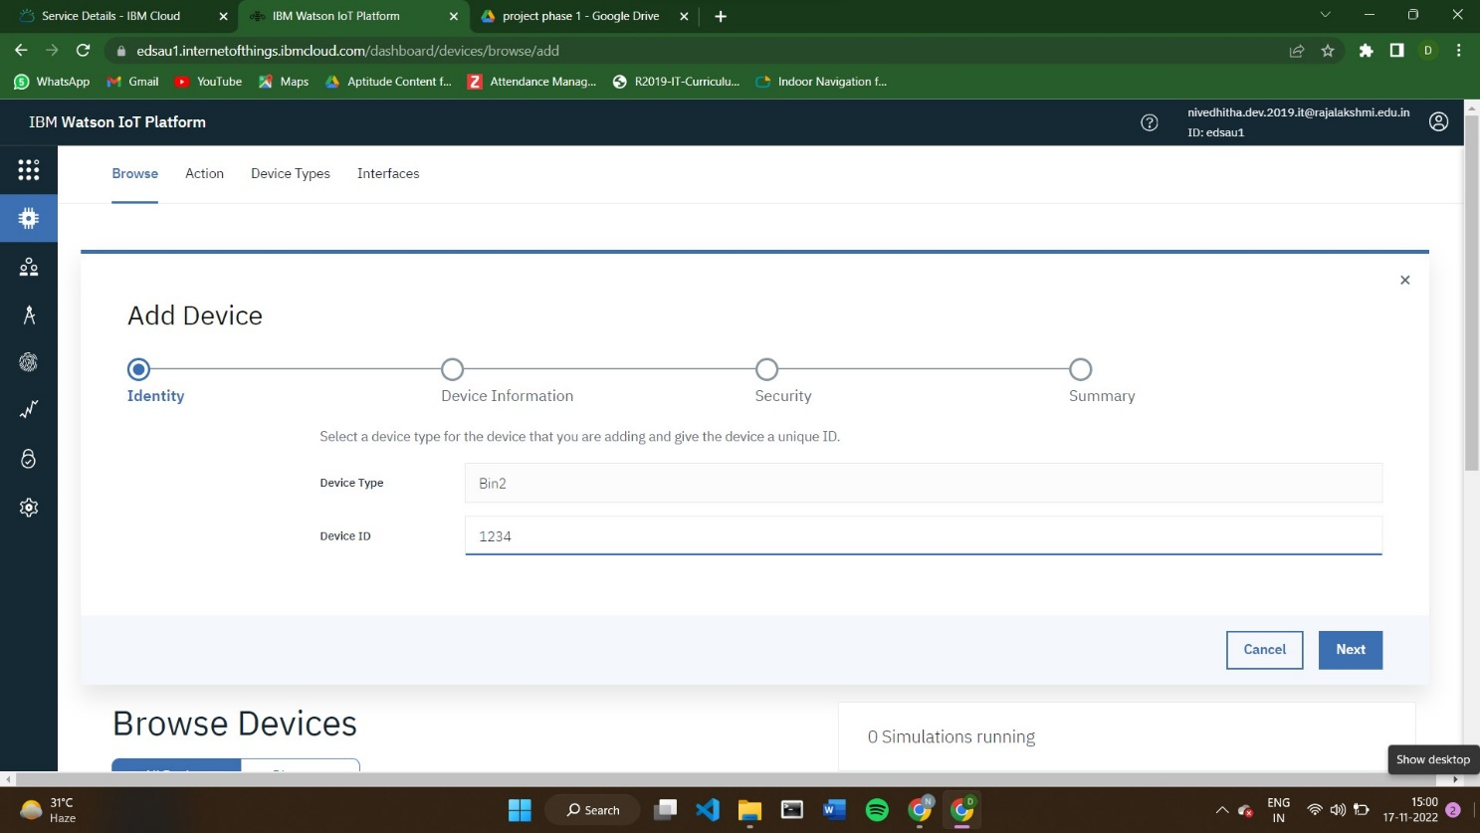

Step – 8: Add the team members to access the devices.

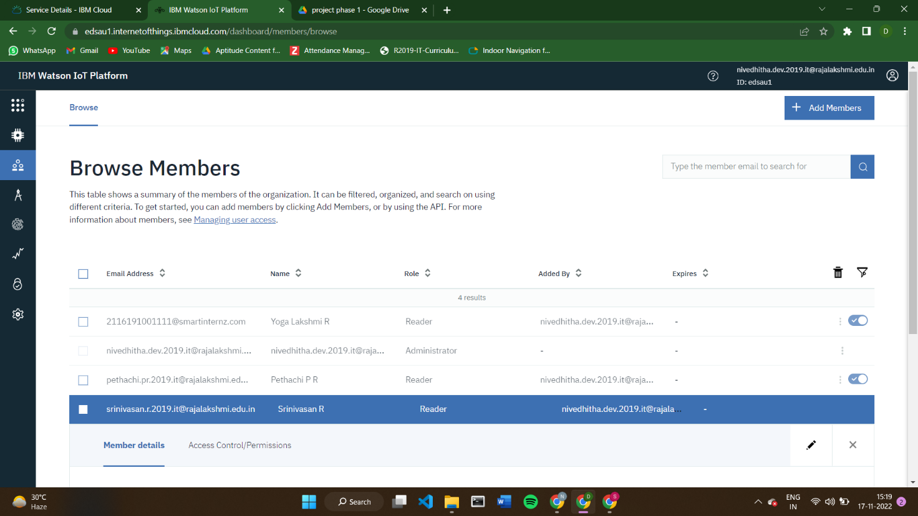

Step – 9: to connect the IoT device to the IBM cloud, create a device in the IBM Watson IOT Platform and get the device credentials

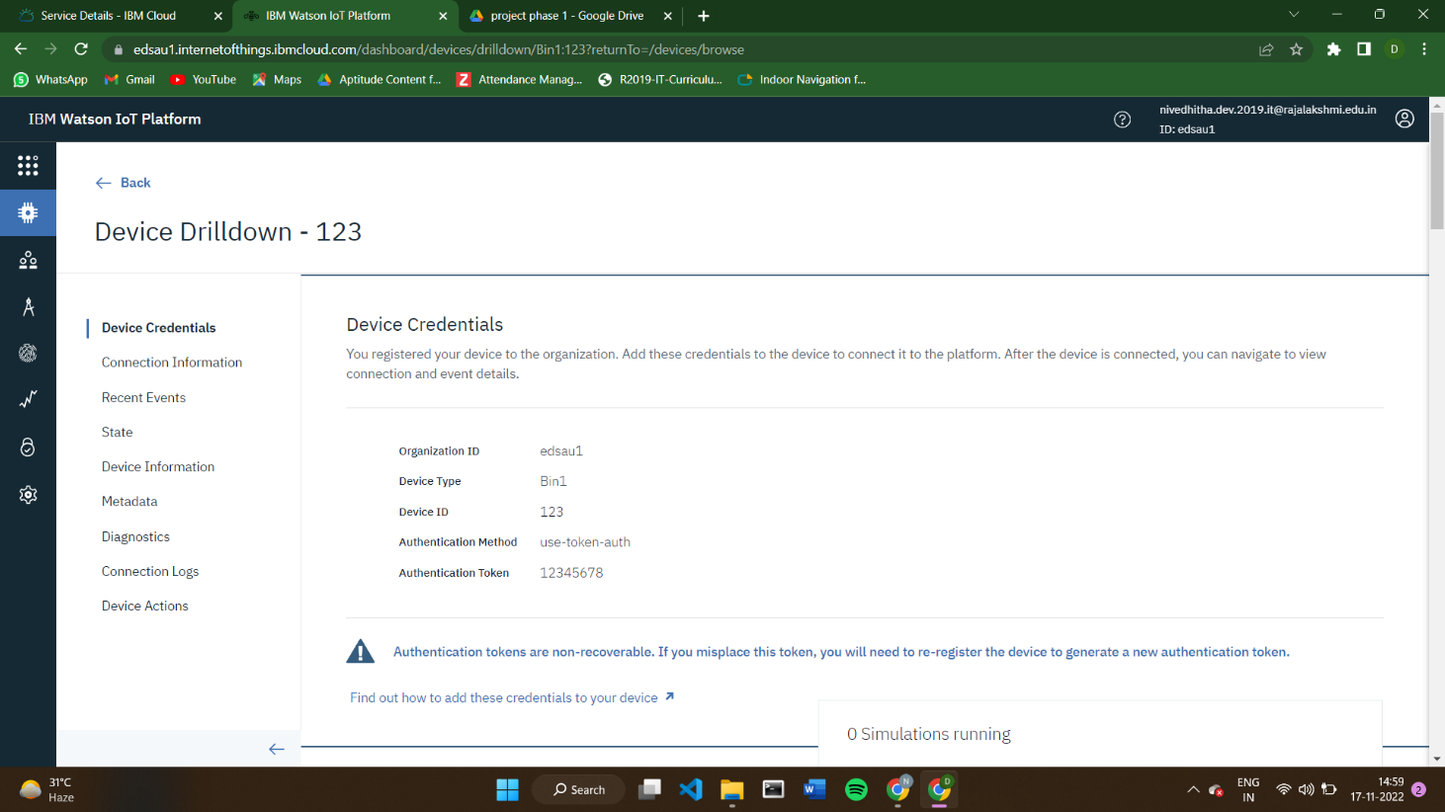

Step – 10: Connect the device with the IoT device and start simulating.

